



Basavarajeswari group of institutions

BALLARI INSTITUTE OF TECHNOLOGY & MANAGEMENT
NACC Accredited Institution*
(Recognized by Govt. of Karnataka, approved by AICTE, New Delhi & Affiliated to Visvesvaraya Technological University, Belagavi)
"JnanaGangotri" Campus, No.873/2, Ballari-Hospet Road, Allipur, Ballar1-583 104 (Karnataka) (India)
Ph: 08392 – 237100 / 237190, Fax: 08392 – 237197

DEPARTMENT OF CSE(DATA SCIENCE)

A Mini-Project Report On

“Chart Sales Performance and Budget Analysis Dashboard Using Power BI ”

A report submitted in partial fulfillment of the requirements for the

DATA VISUALIZATION WITH POWER BI

Submitted By

Name: L Rohit Kumar USN: 3BR23CD047
Under the Guidance of Mr.Sundeep Sindhanoor Asst. Professor
Dept of CSE (DATA SCIENCE),
BITM, Ballari

Visvesvaraya Technological University

Belagavi, Karnataka 2025-2026





BASAVARAJESWARI GROUP OF INSTITUTIONS
BALLARI INSTITUTE OF TECHNOLOGY & MANAGEMENT
NACC Accredited Institution*
(Recognized by Govt. of Karnataka, approved by AICTE, New Delhi & Affiliated to Visvesvaraya Technological University, Belagavi)

"JnanaGangotri" Campus, No.873/2, Ballari-Hospet Road, Allipur, Ballari-583 104 (Karnataka) (India)
Ph: 08392 – 237100 / 237190, Fax: 08392 – 237197

DEPARTMENT OF CSE (DATA SCIENCE)

This is to certify that the OPEN-ENDED PROJECT of DATA VISUALIZATION WITH POWER BI “Chart Sales Performance and Budget Analysis Dashboard Using Power BI”
has been successfully presented by L Rohit Kumar bearing USN 3BR23CD047 student of semester B.E for the partial fulfillment of the requirements for the award of Bachelor Degree in CSE(DS) of the BALLARI INSTITUTE OF TECHNOLOGY& MANAGEMENT, BALLARI during the

academic year 2025-2026.

Signature of guide Signature of HOD

Mr. Sundeep Sindhanoor Dr. Aradhana D

The satisfactions that accompany the successful completion of our mini project on “Chart Sales Performance and Budget Analysis Dashboard Using Power BI ” would be incomplete without the mention of people who made it possible, whose noble gesture, affection, guidance, encouragement and support crowned my efforts with success. It is our privilege to express our gratitude and respect to all those who inspired us in the completion of our mini-project. We are extremely grateful to our Guides Mr.Sundeep Sindhanoor for their noble gesture, support co-ordination and valuable suggestions given in completing the mini-project. We also thank Dr. Aradhana D, H.O.D. Department of CSE(DS), for his co-ordination and valuable suggestions given in completing the mini-project. We also thank the Principal, Management and non-teaching staff for their co-ordination and valuable suggestions given to us in completing the project.

NAME USN

L Rohit Kumar
3BR23CD047

Table of Contents
Ch No | Chapter Name | Page
1 | Introduction  - About the project  - Language used | 1-2
2 | Scope of the project  - Problem statement  - Objectives | 3-4
3 | System requirements  - Functional Requirements  - Non-Functional Requirements  - Hardware Requirements  - Software Requirements | 5-6
4 | Methodology  - Data Collection  - Data Preparation(Power Query)  - Data Visualization  - Filters and Interactivity  - Dashboard Design  - outcome | 7-8

5 | Implementation  - Dataset Description  - Data Loading  - Data Transformation(Power Query)  - Data Modelling  - DAX Measures(Key Calculations)  - Dashboard Visualization  - Filters / Slicers  - Dashboard Layout  - Integration  - Final output | 9-10
6 | Result | 11-13
 | Conclusion | 14
 | References | 15

ABSTRACT

This project presents the development of an interactive Sales Performance and Budget Analysis Dashboard using Power BI. The primary objective of the dashboard is to transform raw sales data into meaningful insights that support better decision-making. The dashboard provides a comprehensive view of key performance indicators such as total sales, budget, and variance, enabling users to compare actual performance against planned targets.
The system utilizes Power BI for data visualization, Power Query for data cleaning and transformation, and DAX for performing calculations and creating measures. Various visual elements such as bar charts, line charts, pie charts, and tables are used to represent data in an intuitive and user-friendly manner. Interactive features like slicers and filters allow users to explore data dynamically based on different parameters such as category, month, and customer.
The dashboard helps in identifying sales trends, high-performing categories, and areas where performance deviates from the budget. By providing clear and interactive visual insights, the project demonstrates how business intelligence tools like Power BI can enhance data analysis and support strategic planning.

CHAPTER 1

INTRODUCTION

About the Project

The "Chart Sales Performance and Budget Analysis Dashboard Using Power BI" is a mini-project developed as part of the Data Visualization with Power BI course at the Department of CSE (Data Science), Ballari Institute of Technology & Management. The project aims to transform raw sales and budget data into a meaningful, interactive, and visually appealing dashboard.
Power BI, developed by Microsoft, is a business analytics service that provides interactive visualizations and business intelligence capabilities with an interface simple enough for end users to create their own reports and dashboards. This project leverages Power BI Desktop to design a single-page analytical dashboard titled "Chart Sales Performance and Budget Analysis Dashboard Using Power BI"
The dashboard consolidates sales figures, budgeted targets, and derived metrics (such as variance and variance percentage) across multiple dimensions including product categories, sub-categories, time (months), and geographic regions (countries). End users — whether business analysts, managers, or stakeholders — can interactively filter and drill down into the data to derive actionable insights.

Language Used

The primary tools and languages used in this project include:

    - Power BI Desktop – for data visualization and dashboard creation
    - DAX (Data Analysis Expressions) – for creating calculated measures and KPIs
    - Power Query (M Language) – for data cleaning, transformation, and preprocessing
    - Data Sources – structured datasets (CSV/Excel) containing IPL match and player statistics

CHAPTER 2

SCOPE OF THE PROJECT

Problem Statement

Organizations often struggle with siloed data spread across multiple spreadsheets and systems, making it difficult to obtain a unified view of sales performance versus budget allocations. Sales managers and executives require a single, consolidated view that allows them to quickly identify underperforming product categories, regions, or time periods.
The challenge is to integrate data from multiple sources sales transactions, budget allocations, product master data, and territorial information and present it in a digestible, interactive format that enables rapid decision-making without requiring deep technical expertise.

Objectives

- To design and develop a single-page interactive Power BI dashboard for Sales Performance and Budget Analysis.
2. To compute and display key KPIs: Total Sales, Total Budget, Sales Variance (Sales – Budget), and Variance Percentage.
3. To provide a comparative view of actual sales against budgeted figures across Product Categories and Sub-Categories.
4. To visualize monthly sales trends and budget tracking using a line chart.
5. To analyse sales distribution and variance across months using a pie chart.
6. To display product-level sales details through a tabular view.
7. To present geographic sales performance (by Country) using a column chart.
8. To enable user interactivity through slicers and cross-filtering for dynamic data exploration.

CHAPTER 3
SYSTEM REQUIREMENTS

Functional Requirements

1.The system shall load and refresh data from Excel/CSV source files containing Sales, Budget, Product, Calendar, and Territory tables.
2.The system shall compute DAX measures for Total Sales, Total Budget, Variance, and Variance%.
3.The system shall display KPI Cards, Bar Charts, Line Chart, Pie Chart, Table, and Column Chart as visualizations.
4.The system shall support interactive slicers and cross-filtering between all visual components.
5.The system shall allow drill-down from Category to Sub-Category level in bar charts.

Non-Functional Requirements

- Performance: The dashboard shall load within 5 seconds on standard hardware.
2. Usability: The interface shall be intuitive and require no specialized training to operate.
3. Accuracy: All DAX calculations shall produce mathematically correct results consistent with the source data.
4. Scalability: The data model shall accommodate increasing data volume without redesign.
5. Maintainability: The report shall be structured so that new data periods can be appended with minimal effort.

3.3 Hardware Requirements

    - Operating System: Windows 10, Windows 11, or Windows Server 2016/2019/2022.
    - Processor (CPU): 1.4 GHz 64-bit (x64) processor or better.
    - Memory (RAM): 4 GB RAM.
    - Storage: 2 GB of available hard disk space (for the Power BI Desktop application and cache).
    - Display: 1440 x 900 or 1600 x 900 (16:9) resolution.

Software Requirements

    - Development: Microsoft Power BI Desktop (requires Windows 10/11).

    - Data Source: CSV files (can be managed via Microsoft Excel or standard text editors).

    - Deployment & Hosting: Power BI Service (cloud platform for publishing and sharing the dashboard).
    - End-User Access: Any modern web browser (Google Chrome, Microsoft Edge, Safari) or the Power BI Mobile App (iOS/Android) for viewing the report.

CHAPTER 4
METHODOLOGY

The development of this Power BI dashboard followed a structured methodology consisting of five major phases: Data Collection, Data Preparation, Data Modelling, Visualization Design, and Testing. This structured approach ensures accuracy, reliability, and usability of the final dashboard.

4.1 Data Collection

  - IPL datasets were collected from reliable sources in CSV/Excel format
  - Data includes matches, players, teams, venues, runs, wickets, and seasons

4.2 Data Preparation

The project uses a fictional but realistic sales dataset comprising five interrelated tables. The data was collected and organized in Excel format before being imported into Power BI Desktop:
1.Sales Table: Contains transactional records of actual sales with columns for Product ID, Date, Country, and Sales Amount.
2. Budget Table: Contains budgeted sales targets for each product and month, enabling variance analysis.
3. Product Table: A dimension table containing Product Name, Category, and Sub-Category for each product.
4. Calendar Table: A date dimension table containing Month, Quarter, and Year fields for time intelligence.
5. Territories Table: Contains geographic data mapping sales regions to Country names.

4.3 Data Visualization

After completing data preparation and modelling, the following visual components were designed on a single Power BI report page. Each visual was selected based on the type of analysis it best represents:
- KPI Cards (x4): Provide at-a-glance totals for Sales, Budget, Variance, and Variance%.
- Clustered Bar Chart (x2): Enable side-by-side comparison of Sales vs Budget and Variance breakdown by Category/Sub-Category.
- Line Chart: Shows monthly trends of Sales and Budget over time.
- Pie Chart: Displays variance contribution by month.
- Table Visual: Provides detailed product-level sales figures.
- Column Chart: Compares sales performance across different countries.

4.4 Filters and Interactivity

Interactivity is a core feature of the dashboard. The following mechanisms were implemented:
1.Cross-filtering: Clicking on any visual element automatically filters all other visuals on the page.
2. Action Button: A navigation or reset button was added to enhance user experience.
3. Drill-down: Bar charts support drilling from Category to Sub-Category level.
4. Tooltip: Custom tooltips display additional context on hover.

2.Dashboard Design

4.5 Dashboard Design
The overall dashboard is titled 'Sales Performance and Budget Analysis Dashboard using Power BI' (displayed in Comic Sans MS, 24pt, gold color). The design follows these principles:
1. Single-page layout for quick overview of all KPIs and charts.
2. Consistent color theme with a dark background and contrasting chart colors.
3. Logical grouping: KPI cards at top, comparison charts in the middle, trend and detail visuals at the bottom.
4. Clear labels and titles on all visual components for readability.

CHAPTER 5
IMPLEMENTATION

The implementation phase focuses on converting the designed methodology into a working Power BI dashboard by integrating data, applying transformations, and building interactive visualizations.

5.1 Dataset description
Imported dataset into Power BI.

5.2 Data loading

• Cleaned data using Power Query
• Converted data types

5.3 Data transformation (Power Query)

· Cleaned data using Power Query
· Converted data types

5.4 Data Modeling

· Established relationships
· Structured data

5.5 DAX Measures
- Total Sales = SUM(Sales)
- Variance = Sales - Budget

5.6 Dashboard Visualization
- Created multiple visuals
- Organized layout

5.7 Filters / Slicers

· Drill-down
· Dynamic visuals

CHAPTER 6
RESULT

The dashboard successfully transforms raw sales data into meaningful insights. Key outcomes include:
- Clear visualization of total sales, budget, and variance
- Identification of top-performing categories
- Analysis of monthly sales trends
- Understanding of customer contribution
Interactive features allow users to explore data dynamically, improving usability and analysis.
From a technical perspective, the project demonstrates effective use of:
- Power Query for preprocessing
- Data modeling for relationships
- DAX for calculations

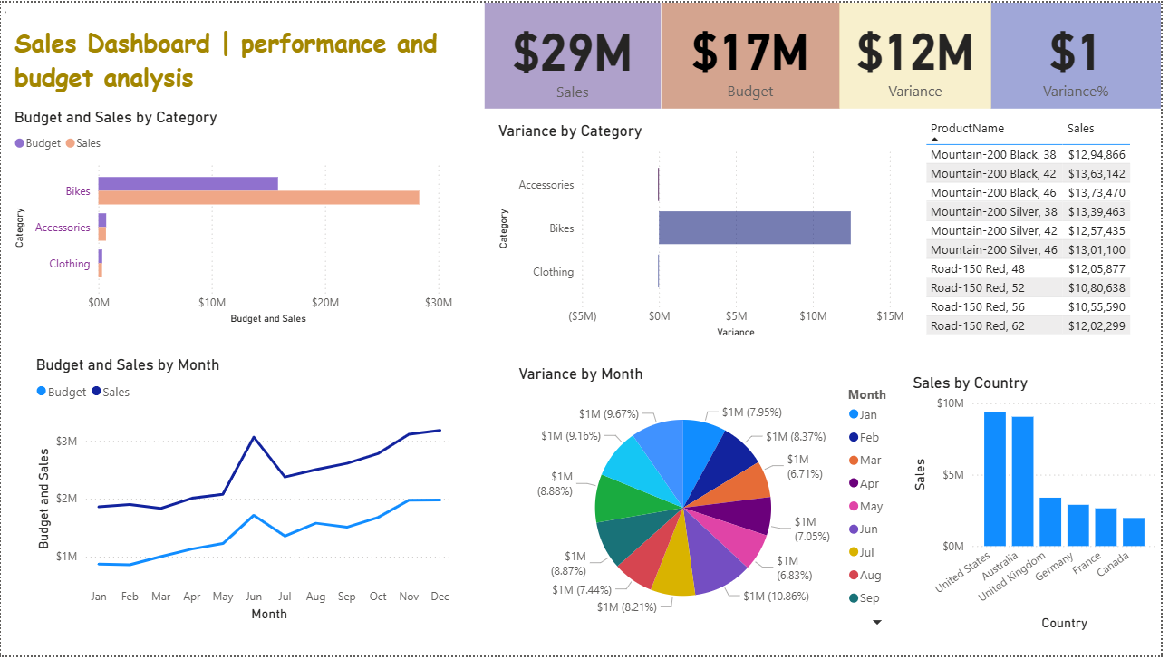

CONCLUSION

This mini-project successfully demonstrates the power of Microsoft Power BI as a business intelligence and data visualization tool. The Sales Performance and Budget Analysis Dashboard developed in this project provides a comprehensive, interactive, and visually rich analytical solution that enables stakeholders to monitor sales performance, track budget adherence, and identify variance trends across multiple dimensions.

The project covered the complete lifecycle of a Power BI report — from raw data collection and ETL processing in Power Query, through relational data modelling using a Star Schema, to the creation of DAX measures for computed KPIs, and finally the design of a polished single-page dashboard. The dashboard's interactivity through cross-filtering and drill-down capabilities significantly enhances its utility for business users.

The project met all stated objectives: the four KPI cards accurately display Total Sales, Total Budget, Variance, and Variance%; all seven chart types render correctly with their respective data fields; and the dashboard is fully interactive. The visual design ensures that both technical and non-technical users can derive insights quickly and effectively.

Future enhancements could include adding row-level security (RLS) for multi-user environments, publishing the report to Power BI Service for cloud-based sharing, integrating real-time data sources via DirectQuery, and expanding the dashboard to multiple pages with a navigation menu for deeper analysis of individual dimensions.

REFERENCES

- Microsoft Corporation. (2024). Power BI Documentation. Retrieved from
https://docs.microsoft.com/en-us/power-bi/
(Reference for Power BI features, dashboard creation, and data visualization techniques)

- Ferrari, A., & Russo, M. (2019). The Definitive Guide to DAX: Business Intelligence for Microsoft Power BI, SQL Server Analysis Services, and Excel. Microsoft Press.
(Used for understanding and implementing DAX calculations and measures)

- Microsoft Corporation. (2024). Power Query M Language Reference. Retrieved from
https://docs.microsoft.com/en-us/powerquery-m/
(Reference for data cleaning, transformation, and preprocessing techniques)

- Clark, P. (2022). Microsoft Power BI Quick Start Guide. Packt Publishing.
(Used for learning dashboard development and visualization best practices)

- Kaggle. (2024). Sales Dataset for Data Analysis. Retrieved from
https://www.kaggle.com/
(Used as the primary source for sales data including category, product, and customer details)

- Microsoft Learn. (2024). Create Reports and Dashboards in Power BI. Retrieved from
https://learn.microsoft.com/en-us/training/powerplatform/power-bi/
(Reference for building interactive dashboards and reports)

- Tableau. (2024). Data Visualization Best Practices. Retrieved from
https://www.tableau.com/learn/articles/data-visualization
(Used for understanding visualization principles and dashboard design techniques)

